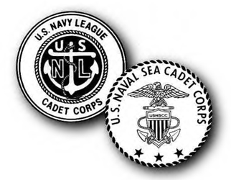
NSCC STAFF APPLICATION CHECKLIST
U.S. Naval Sea Cadet Corps – Kentucky Division

Adult Leader Application

Application Fee ($20 non-refundable)
--A $20.00 renewal fee is due annually.

Request for References (3)
-- Fill out the contact information on each form, give the form to each referral, and request them to send it to the address below.

Report of Medical History

Uniform Agreement

Copy of DD214 (if former military)

Copy of health insurance card

Copy of driver’s license

INSTRUCTIONS:

- Doublecheck to make sure all information is complete and all forms are signed. ALL forms listed above must be submitted in order for an adult volunteer to be enrolled.
- Email all forms to CO@kentuckydivision.org or mail to the below address.
- Payment can be made online at http://www.kentuckydivision.org/payments or by sending a check made out to USNSCC – KYDIV and mailed in with the application packet.
- NHQ will process background screening on each adult volunteer.
- All adult volunteers must complete the following online courses before enrollment will be complete:
  - Officer/Midshipman Study Guide (OMSG)
  - Darkness to Light Child Sexual Abuse Prevention

U.S. Naval Sea Cadet Corps – KY Division, c/o 928 Springwood Ct, Lexington, KY 40515
CO@kentuckydivision.org – 859.502.4077

(revised 07 FEB 17)

